POKEMON TRADING CARD GAME DOCUMENTATION

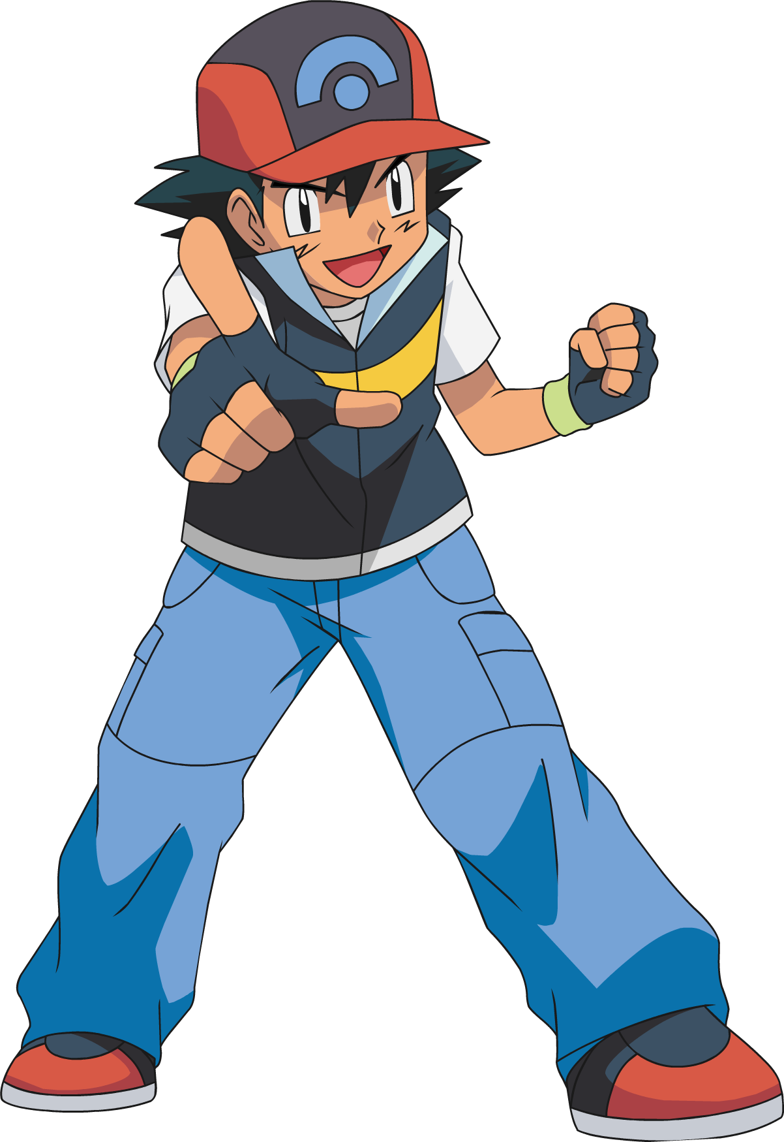

Implementation of Pokémon Trading Card Game

Here is the Pokemon Trading Card Game implemented in Java. There are provisions for accommodating two players to play against one another with 60-card decks of Pokemon cards, Energy cards, and Trainer cards. A basic structure of the game is divided into various parts to provide organized functionality.

Game management is handled by Game.java, the main controller for game initialization, game progression, game win condition and turn order. TurnHandler.java handles turn switching like random determination of the starting player and GameAction.java handles player action like card play, energy attachment and usage of trainer cards. Base classes of the Card System are Card.java (a general-purpose class for all cards), ICard.java (general card attributes), IAttackable.java (for cards that are targetable) and IEffect.java (for effect cards). Pokémon cards are of the class Pokemon.java with HP, attacks and attached energy. Pokemon are instantiated as current Pokémon or as benched Pokemon and implement the IAttackable interface. Energy.java is the energy card powering Pokemon attacks and one can attach it once during each turn. There are one-use cards of class Trainer.java with unique abilities and implement the IEffect interface.

The Player Management is done through Player.java that keeps track of each player's state like their active Pokemon, their up to 5 bench Pokémon, hand, prize cards, and turn actions available. The Battle System is done through Battle.java that manages the play of attacks, damage calculations, fainted Pokémon, and prize card collection. Support Classes include Deck.java that deals with the 60-card deck through card drawing, shuffling, and adding cards to the deck. Attack.java sets the attributes of the attacks, energy requirements, damage calculations, and attack execution. UIHelper.java deals with the presentation of cards, game state, messages, and rules.

Two enums are employed to declare major aspects of the game: PokemonType.java to declare Pokémon types and associate them with basic Pokémon and TrainerEffect.java to declare trainer card effects such as Potion (restore 30 HP), Switch (switch Pokémon) and Professor's Research (draw 7 cards).

The structure of the Game Flow is linear. During the Setup Phase, players construct decks, shuffle, draw 7 initial cards, set out 6 prize cards and active and bench Pokémon. Turn Structure is where one draws one card and executes any action that is available such as playing a Basic Pokémon, attaching energy, playing a Trainer card, attacking, or retreating the active Pokémon. These actions end the turn. Winning Conditions are met when one draws all their prize cards, their opponent has no Pokémon in play remaining, or their opponent cannot even draw one card.

At the deck of cards level, it has 24 Pokémon cards (4 of each of the 6 types) and 4 of each of the 4 types of 24 energy cards and 3 of each of the 4 types of 12 trainer cards. It also has more advanced Error Handling including deck size checks, energy attachment based on matching types, legal action checks, null pointer check defense, and management of turn states.

To run the game, users simply run the command java LaunchTcg and provide on-screen prompts for the flipping of the coin, placement of cards, action of turns, and battles. Class Relationships show the Card as an abstract class being extended by Pokemon and Energy and by Trainer. Interfaces such as ICard, IAttackable, and IEffect are also implemented in the game for dynamic action of cards. Game Rules instruct each player to start with 60 cards, receive 7 cards in their initial hand, place 6 reward cards face down and choose their active and bench Pokémon. A player may play one energy attachment, one retreat and one attack each in their turn with the initial player prohibited from attacking during their first turn. Pokémon cards consist of single Basic Pokemon with 60 HP and one attack. Energy cards are of particular types and are required to be played while attacking. Trainer cards are single-use with strong impacts before being discarded.

USER MANUAL
POKEMON TRADING CARD GAME

TABLE OF CONTENTS
- Getting Started
- Game Setup
- Card Types
- Playing the Game
- Actions Guide
- Winning the Game
- Quick Reference
- Troubleshooting

1. GETTING STARTED
To Start the Game:
- Open your terminal
- Go to the game folder
- Type: java LaunchTcg
- Follow the on-screen instruction

2. GAME SETUP
Deck Setup:
- 24 Pokémon cards (6 of each type)
- 24 Energy cards (6 of each type)
- 12 Trainer cards (4 of each type)
Starting the Match:
- Decks are shuffled
- Each player draws 7 cards
- Place 6 prize cards face-down
- Place Basic Pokémon as Active and Bench
First Turn Rule:
- Coin flip decides who starts
- First player cannot attack on their first turn

3. CARD TYPES
Pokémon Cards:
- Basic Pokemon only
- Has HP, Type, and Attacks
- Can be Active or on Bench
Energy Cards:
- Must match Pokémon type
- One attachment per turn
- Needed for attacks
Trainer Cards:
- Potion: Heals 30 HP
- Switch: Swaps Active with Bench Pokémon
- Professor's Research: Discard hand, draw 7 cards

4. PLAYING THE GAME
Turn Steps:
- Draw a card
- Take actions:
  - Play a Basic Pokémon
  - Attach one Energy card
  - Use a Trainer card
  - Retreat Pokémon
  - Attack
- End turn
5. ACTIONS GUIDE
Playing Pokémon:
- Place Basic Pokémon as Active or on Bench (max 5)
Attaching Energy:
- Select an Energy card and attach it to a Pokémon
Using Trainer Cards:
- Follow the instructions on the card
Attacking:
- Select an attack if enough Energy is attached
Retreating:
- Swap Active Pokémon with a Benched Pokémon (once per turn)

6. WINNING THE GAME
Victory Conditions:
- Collect all 6 prize cards
- Opponent has no Pokémon left
- Opponent can’t draw a card

7. QUICK REFERENCE
Key Numbers:
- Deck size: 60 cards
- Starting hand: 7 cards
- Prize cards: 6
- Max bench size: 5
- Energy per turn: 1
- Attacks per turn: 1
Commands:
1 - Play card
2 - Attack
3 - View hand
4 - View bench
5 - End turn
0 - Cancel action

8. TROUBLESHOOTING
Can't Attack?
- Is it your first turn as the starting player?
- Do you have enough Energy?
- Is there an opponent's Pokémon to attack?
Can't Play a Card?
- Is it your turn?
- Have you already attached Energy this turn?
- Is your Bench full?
Invalid Input?
- Enter numbers only when prompted
- Use 0 to cancel an action
- Follow on-screen instructions
For further issues, restart the game if needed.
END OF MANUAL

Starting display menu
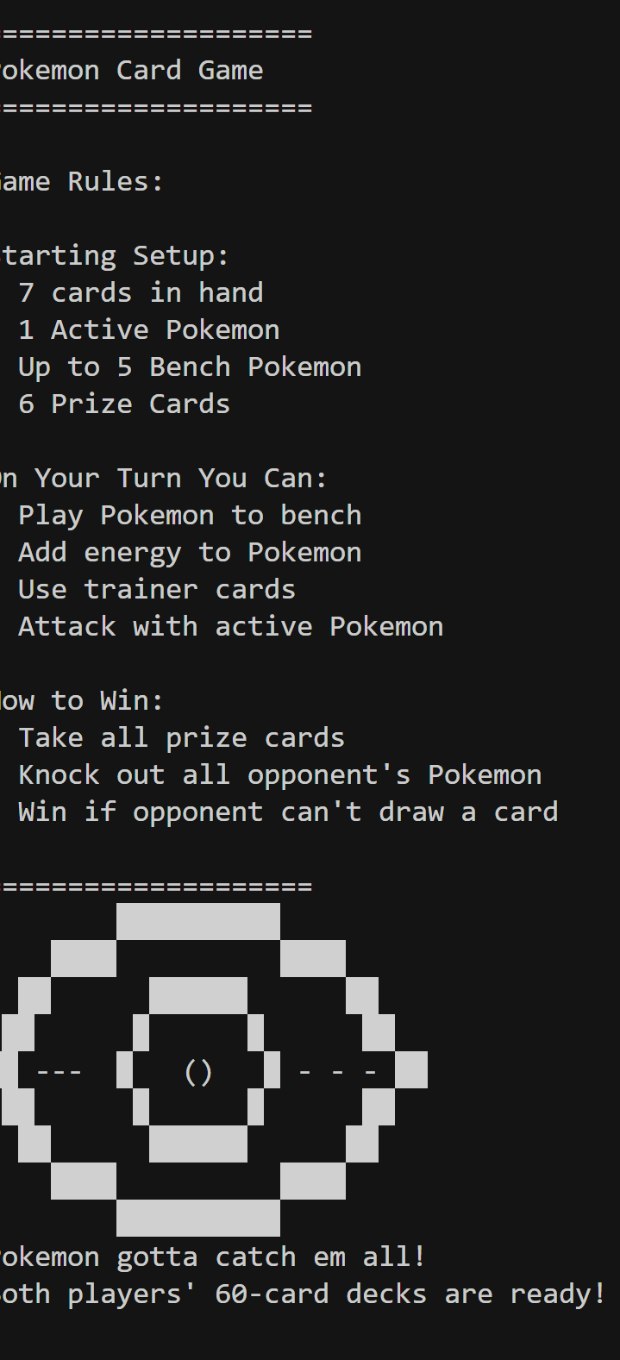
Coinflip output
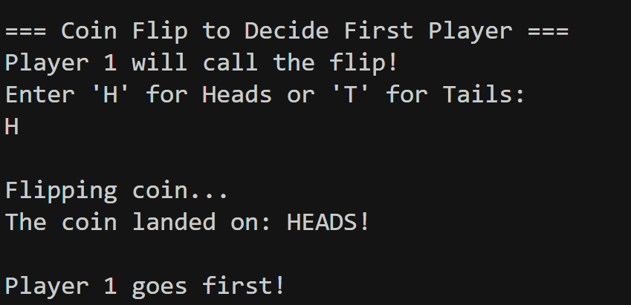

Players hand setup
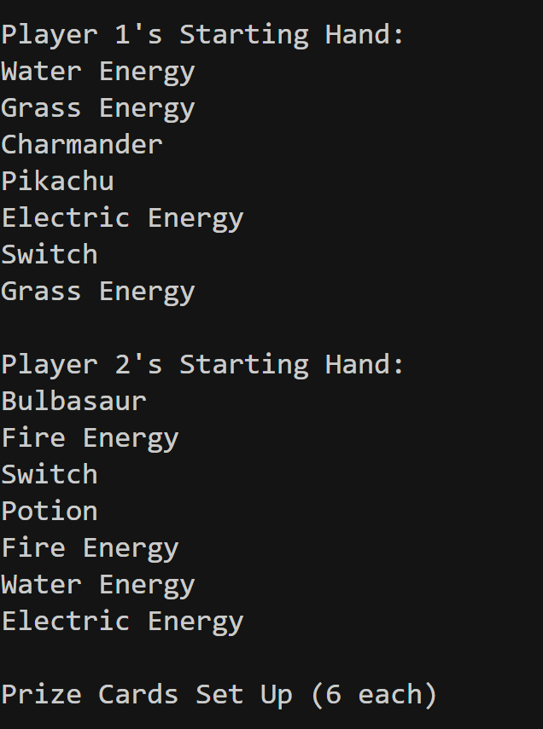

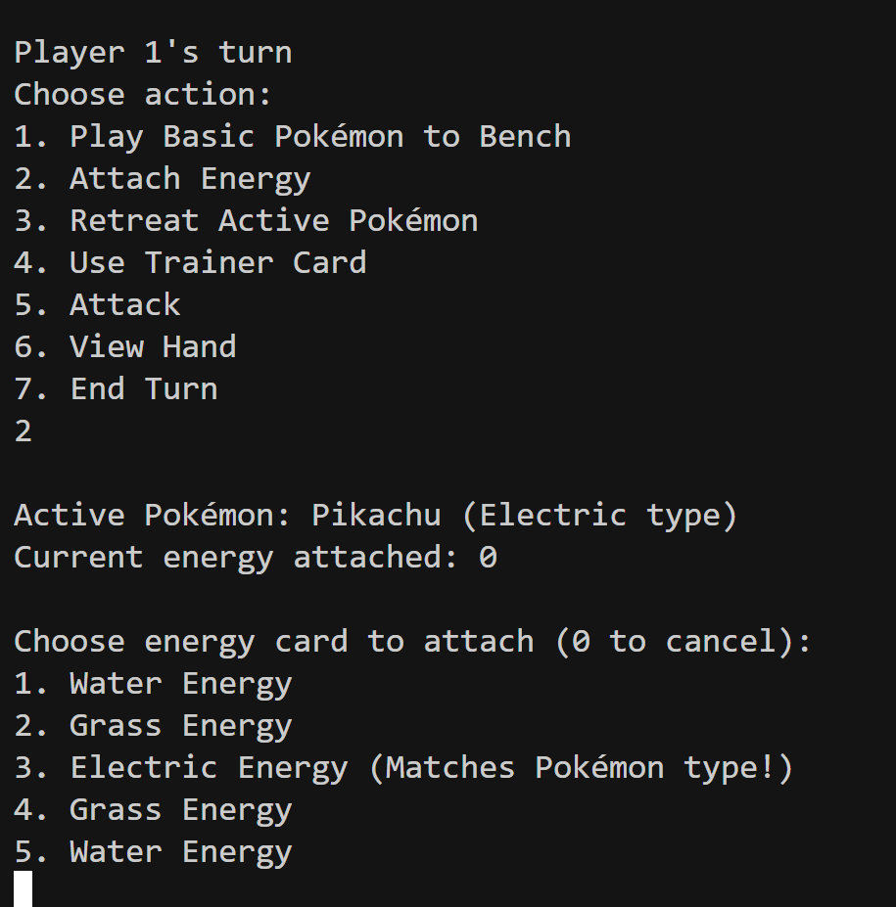
Attach energy
Player can only choose energy related to pokemon type.as shown in picture.if player chooses a wrong energy type,it will prompt out”it can not accept the following energy”.

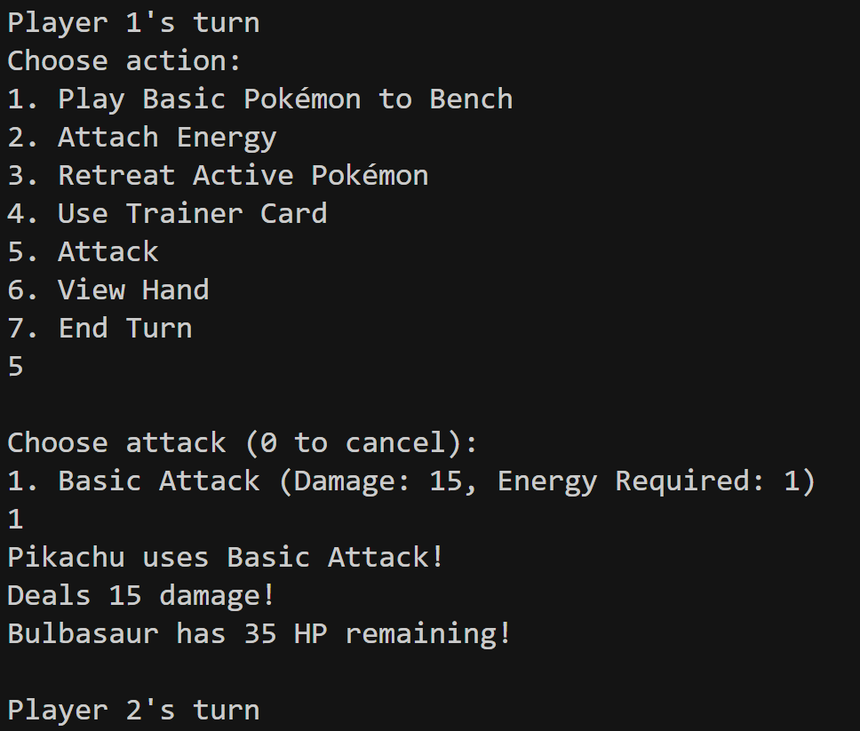

Display Attack
After energy is attached to the active pokemon player can attack.After attack is executed ,it outputs with attack and damage dealt by the opponents pokemon.Then switches turn.

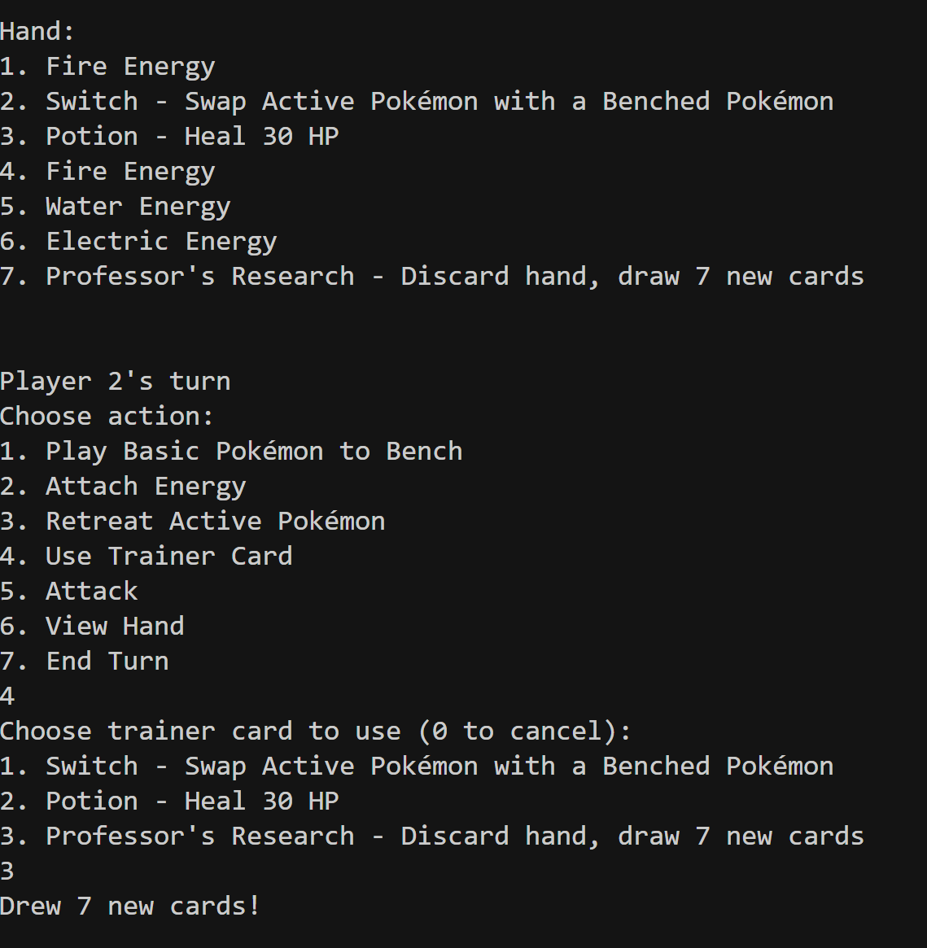

Trainer card Usage
Player can view their hand,if they don't have card to play the game,they can use trainer card like professor research (draws 7 new cards)

New hand after using Trainer
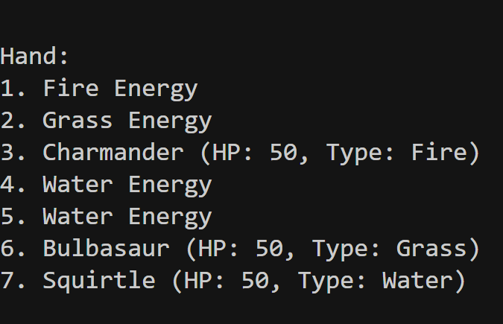

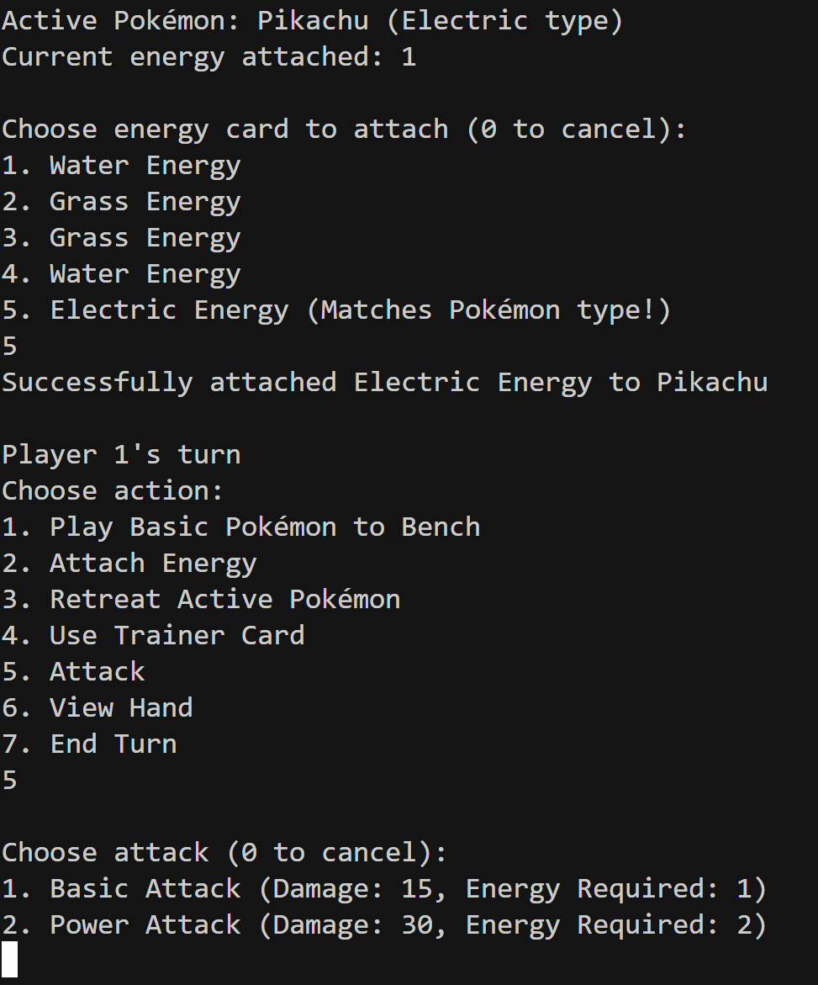
A pokemon has two attacks. If you attach two energies to a pokemon,you unlock a Power attack which has more damage.
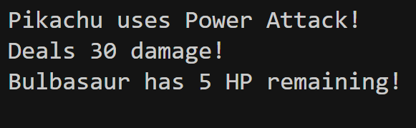

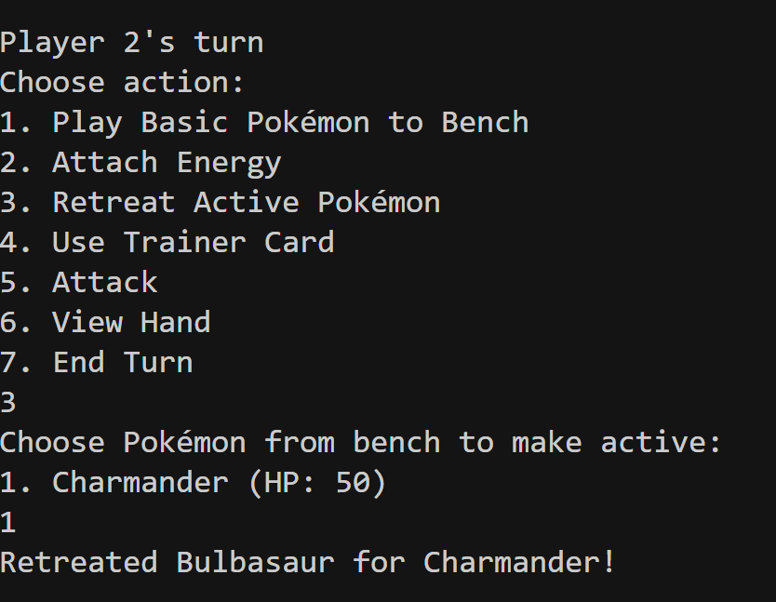
Switching your Bench pokemon to Active state
If player has a pokemon and bench,then they can
retreat their active pokemon and place their bench pokemon active battle ground.

Winning

